LED PAR 12X10 PL

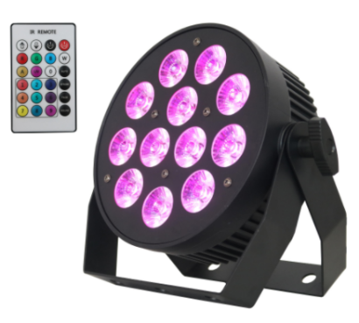

USER MANUAL

Thank you very much for choosing our product. For safety purpose, please read this manual carefully before your operation. This manual included installation and using information. Please install and operate it according to this manual.

Part 1 Product

  - Product introduction
This product is designed for indoor and outdoor use. Suitable applications include wash or effect lighting for architectural, stage or nightclub applications. This product can also be installed for use in signage and advertising using the dynamic functions available with DMX512 control. Direct input of DMX512 signal allows the units to be controlled from any DMX512 controller. This product can be operated as a single unit or in multiple units for large applications.

1.2 Technical Specifications
Voltage: AC100-240V, 50/60Hz
Power: 120W
Light Source: 12X10W RGBW 4in1 ultra bright LED
Lifespan: around 50,000-100,000 hours
Control: DMX 512,4/8 channels
Control mode: DMX 512, Auto mode, Master/Slave Mode,Sound Mode, Remote control
Display: LED display with 4 buttons
Heat dissipation: intelligent temperature control, no fan,no noise
Power connection: Power con connectors input/output
Data connection: 3-pin DMX connectors input/output
LED life: 50,000-100,000 hours
IP rating: IP20
Beam angle: 25 º
Net Weight：2.1KG

1.3 Safety Warning

IMPORTANT:
ALWAYS READ THE USER MANUAL BEFORE OPERATION. PLEASE CONFIRM THAT THE POWER SUPPLY STATED ON THE PRODUCT IS THE SAME AS THE MAINS POWER SUPPLY IN YOUR AREA.
● This product must be installed by a qualified professional.
● Always operate the equipment as described in the user manual.
● A minimum distance of 0.5m must be maintained between the equipment and combustible surface.
● The product must always be placed in a well ventilated area.
● Always make sure that the equipment is installed securely.
● DO NOT stand close to the equipment and stare directly into the LED light source.
● Always disconnect the power supply before attempting and maintenance.
● Always make sure that the supporting structure is solid and can support the combined weight of the products.
● The earth wire must always be connected to the ground.
● Do not touch the power cables if your hands are wet.
ATTENTION:
● This product left the place of manufacture in perfect condition. In order to maintain this condition and for safe operation, the user must always follow the instructions and safety warnings described in this user manual.
● Avoid shaking or strong impacts to any part of the equipment.
● Make sure that all parts of the equipment are kept clean and free of dust.
● Always make sure that the power connections are connected correct and secure.
● If there is any malfunction of the equipment, contact your distributor immediately.
● When transferring the product, it is advisable to use the original packaging in which the product left the factory.
● Shields, lenses or ultraviolet screens shall be changed if they have become damaged to such an extent that their effectiveness is impaired.
● The lamp (LED) shall be changed if it has become damaged or thermally deformed.

PART 2 INSTALLATION

2.1 Mounting:
2.1-1 Hanging
The product can be mounted in a hanging position using the supporting bracket. The bracket should be secured to the mounting truss or structure using a standard mounting clamp. Please note that when hanging the unit a safety cable should also be used
.
2.1-2 Upright
The product can be mounted in an upright or sitting position using the supporting brackets.

NOTE:
The product can be mounted at any angle and in any position. It is possible to further adjust the angle of the product using the two adjustment knobs located on the side of the fixture.

2.2 Special construction for DMX connection.
☆ At last fixture, the DMX cable has to be terminated with a terminator to reduce signal errors. Solder a 120-ohm 1/4W resistor between pin 2(DMX-) and pin 3(DMX+) into a 3-pin XLR-plug and plug it in the DMX-output of the last fixture.
☆ If the controller is 5-pin output, it’s necessary to use an adaptor to transfer signal from 5-pin output to 3-pin XLR-plug or you can connect cables as following:
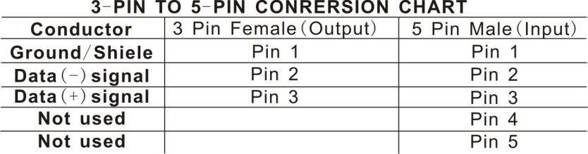

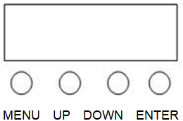

PART 3 Display Panel Operation

3.1 Display panel menu instruction

[MENU] menu selection or return to previous menu.
[UP] press [UP] through the menu list to increase/change the value of the current function.
[DOWN] press [DOWN] through the menu list to decrease/change the value of the current function.
[ENTER] confirm & quit out current function setting.

3.2 Display panel operation instruction
Menu |  | Function
A001 | A001—A512 | DMX Address 001-512
Chnd | 4CH | 4 channels mode
Chnd | 8CH | 8 channels mode
CL01 | CL01—CL15 | 15 static color mixing modes, color selection by up and down keys  Strobe mode St00-St16 after confirmation, adjust by up and down keys
CC99 | CC01-CC99 | Color Change, Speed from slow to fast (01-99)
EE99 | EE01-EE99 | Color Pulse,Speed from slow to fast (01-99)
FF99 | FF01-FF99 | Color Gradient,Speed from slow to fast (01-99)
ST99 | ST01-ST99 | Strobe, 01-99
SOU1 | SOU1 | Sound mode 1
SOU1 | SOU2 | Sound mode 2
SOU1 | SOU3 | Sound mode 3
SOU1 | SOU4 | Sound mode 4
IRCL | ON/OFF | Remote control ON/OFF
R255 | R000-R255 | R manual dimming
G255 | G000-G255 | G manual dimming
B255 | B000-B255 | B manual dimming
W255 | W000-W255 | W manual dimming
T000 | OFF/70-100 | Display current temperature

3.3 DMX Channel instruction
4 Channel | Function | DMX Value | Description
1 | Red | 0-255 | Red dimming,0-100%
2 | Green | 0-255 | Green dimming,0-100%
3 | Blue | 0-255 | Blue dimming,0-100%
4 | White | 0-255 | White dimming,0-100%

8 Channel | Function | DMX Value | Description
1 | Dimmer | 0-255 | Dimmer,0-100%
2 | Red | 0-255 | Red dimming,0-100%
3 | Green | 0-255 | Green dimming,0-100%
4 | Blue | 0-255 | Blue dimming,0-100%
5 | White | 0-255 | White dimming,0-100%
6 | Strobe | 0-10 | No function
6 | Strobe | 11-255 | Strobe from slow to fast
7 | Auto Mode | 0-9 | No function
7 | Auto Mode | 10-50 | Static Colors (CH8 choose color)
7 | Auto Mode | 51-100 | Colors Jump
7 | Auto Mode | 101-150 | Colors Fade
7 | Auto Mode | 151-200 | Colors Pulse
7 | Auto Mode | 201-220 | Sound Mode 1
7 | Auto Mode | 221-240 | Sound Mode 2
7 | Auto Mode | 241-255 | Sound Mode 3
8 | Auto Speed | 0-255 | Auto speed, slow to fast

